**FYP-1**

Mid Evaluation Report

**F21-38-D-HospitalAid**



**Dated: 22nd October, 2021**

**Members:**

Mr. Hassan Shahzad 18i-0441

Ms. Sana Ali Khan 18i-0439

**Supervisor:**

Mr. Syed Muhammad H. Mustafa

Anti-Plagiarism Declaration

This is to declare that the above FYP report produced under the title **Hospital Aid** is the sole contribution of the author(s) and no part hereof has been reproduced on **as it is** basis (cut and paste) which can be considered as **Plagiarism.** All referenced parts have been used to argue the idea and have been cited properly. I/We will be responsible and liable for any consequence if violation of this declaration is determined.

**Date: 22nd October, 2021**

**Member 1**

Hassan Shahzad

18i-0441

**Member 2**

Sana Ali Khan

18i-0439

**Supervisor**

Mr. S. Muhammad H. Mustafa

Abstract

A hospital is an environment that is busy, always in demand yet frequently understaffed. Our system would allow for hospital staff to perform less manual supervision and direct their energy towards other, perhaps more critical activities. A digital monitoring system is also undoubtedly more reliable and consistent. The appropriate staff would rapidly be notified of any incidents and be able to address them. Additionally, the administration would benefit from a neat summation and statistics of the incidents.

Table of Contents

**TABLE OF CONTENTS**

**1.** **Introduction** 5

**2.** **Literature Review** 5

**3.** **Project Vision** 6

3.1. Problem Statement 6

3.2. Business Opportunity 6

3.3. Objectives 7

3.4. Project Scope 7

3.5. Constraints 7

3.6. Target Audience 7

**4.** **Software Requirements Specification** 8

4.1. List of Features/Functional Requirements 8

4.2. Quality Attributes/Non-functional Requirements 8

**5.** **Project Timeline** 9

**6.** **High Level Use Cases** 10

6.1. Use Cases List 10

6.2. Use Cases 10

6.3. Use Case Diagram 14

**7.** **Iteration – 1** 15

7.1. Introduction 15

7.2. Expanded Use Cases 16

7.3. System Sequence Diagrams 18

*7.3.1.* *Use case id: UC-104* 18

*7.3.2.* *Use case id: UC-105* 19

7.4. Operation Contracts 19

*7.4.1.* *Contract use case id: UC-104* 19

*7.4.2.* *Contract use case id: UC-105* 20

**8.** **Architecture Diagram** 20

**9.** **Data Flow Diagram** 20

9.1. Level 0 20

9.2. Level 1 21

9.3. Level 2 21

**10.** **Sequence Diagram** 22

**11.** **Domain Model** 22

**12.** **Class Diagram** 23

**13.** **Implementation details** 23

13.1. Empty Counter Detection 23

*13.1.1.* *Dataset Pre-processing:* 23

*13.1.2.* *Training and testing of model* 24

13.2. Face Mask Detection 25

*13.2.1.* *Dataset Pre-processing:* 25

*13.2.2.* *Training and testing of model* 25

13.3. Social Distancing Monitoring 26

*13.3.1.* *Dataset Pre-processing:* 26

*13.3.2.* *Training and testing of model* 27

13.4. Backend Algorithm (YOLO) 27

*13.4.1.* *Why Choose YOLO?* 27

*13.4.2.* *How YOLO Works* 28

*13.4.3.* *YOLO Architecture* 28

**14.** **References** 29

# **Introduction**

HospitalAid is a multi-platform application that aims to assist hospitals by removing the need for manual oversight of patients and hospital staff. It will monitor the hospital environment through the camera feed, notice medical abnormalities/incidents and alert appropriate personnel to address the situation.

Detecting an anomaly will be done purely through computer vision, by performing real-time analysis of the live video feed coming in from the hospital’s existing surveillance infrastructure. Our system will have various deep learning models that will be trained to notice particular types of anomalies. Alerts will be sent to hospital staff via a mobile app, and incident statistics will be reported to the hospital administration through a web portal.

This system will integrate into the hospital’s existing infrastructure, enable automatic monitoring of patients and staff and create a better, safer environment.

# **Literature Review**

* **YOLOv3: An Incremental Improvement**

YOLO (you only look once) is an object detection algorithm that works best for real-time detection. This paper discusses the improvements that YOLOv3 has brought upon its predecessors – increasing the layers in the neural network, detection at three scales, more bounding boxes and a faster, more accurate algorithm.

* **Face mask detection using YOLOv3 and faster R-CNN models: COVID-19 environment**

In this paper, two object detection models are suggested as advanced face detection approaches. Both YOLOv3 and faster R-CNN models are trained on a dataset of masked and unmasked people; the article proposes an efficient real-time deep learning-based technique to automate the process of detecting masked faces, where each masked face is identified in real-time with the help of bounding boxes.

* **Patient Monitoring by Abnormal Human Activity Recognition Based on CNN Architecture**

One research domain for video analysis and understanding is of human action recognition. This paper presents a real-time application of it – monitoring patients and identifying abnormal activities e.g., vomiting and coughing. YOLO network was utilized as the CNN model, and trained upon a dataset of annotated patient videos. The proposed model would output multi-class abnormal action detection, with an accuracy of 96.8%.

* **Monitoring COVID-19 social distancing with person detection and tracking via fine-tuned YOLO v3 and Deep sort techniques**

This article proposes a deep learning-based framework for automating the task of monitoring social distancing using video. The proposed framework utilizes the YOLO v3 object detection model to segregate humans from the background and deep sort approach to track the identified people with the help of bounding boxes and assigned IDs. The results of the YOLO v3 model are further compared with other popular models, e.g., faster region-based CNN (convolution neural network) and single shot detector (SSD). The pairwise vectorized L2 norm is computed based on the three-dimensional feature space obtained by using the centroid coordinates and dimensions of the bounding box. From the experimental analysis, it is observed that the YOLO v3 with deep sort tracking scheme displayed best results to monitor the social distancing in real-time.

# **Project Vision**

## Problem Statement

**“How to efficiently monitor a hospital 24/7?”**

Consider a hospital environment: always busy and frequently understaffed. There are hundreds of things going on at any given moment, and it is impossible for a hospital to ensure everything is running perfectly – every patient attended to, every anomaly noticed and corrected, every employee error noticed and so on.

It is necessary, however, to monitor patients and employees; patients may require attention or urgent care at any moment and it is vital that hospital staff be available at their post when they are required to be present. This is done manually (e.g., a nurse may notice a patient needs medical attention or the manager might observe the reception is empty.) Manual oversight might be the only option for now, but it is unreliable and at risk of human error.

A patient may suffer from an incident e.g., fainting and no-one may be around to notice they need aid. Perhaps a nurse was supposed to be attending their room but all the nurses are absent from their station. Or a doctor may not be wearing their mask while attending a sick person, and falls ill themselves. These are just a few examples of incidents that could have been easily mitigated, had they just been observed quickly and attended to.

Many hospitals, especially private ones, already have some form of digital surveillance. But what do they do with that? Monitor for possible security incidents, perhaps notice any abnormal medical incidents – but all this is done by manually viewing the footage only after the fact.

## Business Opportunity

* **Assisting Hospital Patients/Staff**: Manual oversight of patients and staff is laborious, time-consuming and not completely reliable. With HospitalAid in place, there would be a tireless system using the live video feed to monitor the environment, detect an anomaly and send out alerts.
* **Report of Incident Statistics**: Noticing an incident/anomaly and sending out alerts is obviously beneficial for patients, staff and the hospital as a whole. HospitalAid would not just be doing this, but would also collect data on incident statistics and present them for the administration to see. For example, a particular hospital might learn how many times in a day the reception was empty.

## Objectives

1. Dataset collection
2. Data pre-processing
3. Training models to detect
   1. masked/unmasked faces
   2. people within vision of interest
   3. certain actions/behaviors of people
4. System for sending alerts
5. Generating reports of incident statistics

## Project Scope

The digital surveillance system in a hospital will observe the hospital environment, staff and patients; the video feed received will be tested by our system. If it detects any sort of abnormality (choking, empty reception, fainting etc.), an alert message will be generated and sent to the concerned staff/personnel (nurses, doctors, security team, administration etc.) Additionally, logs of every abnormality would be maintained and records would be saved in a database with timestamps for administration to view.

## Constraints

* Detecting a person’s actions or behavior is difficult if they are at the edge of vision of interest
* Training a model requires significant amount of time, effort and data – adding new actions to detect would be very hard
* Live video feed will need to be passed to the models, requiring a backend server for them to run on
* If the camera quality is poor, then model accuracy will suffer
* Poor lighting in the hospital environment could also lead to incorrect/missing predictions
* A full-time internet connection will be required for forwarding video feed to server

## Target Audience

Target audience includes all hospitals that have a digital surveillance system and want to monitor the hospital environment more extensively.

# **Software Requirements Specification**

## List of Features/Functional Requirements

The major functions/features of the system will be:

* **Object Detection:** The live camera feed is analyzed frame-by-frame and passed through trained models to identify particular objects e.g., person
* **Object Classification:** Some objects e.g., faces mean nothing on their own, they will be further classified into right and wrong categories.
* **Activity Recognition:** System will monitor the environment and observe for the occurrences of specific activities i.e., medical abnormalities such as fainting.
* **Alert Generation:** For any abnormality or incident observed, an alert will be sent to the appropriate hospital staff.
* **Incident Report:** Hospital administration will be provided with a report of incident statistics, generated by the system after a set time interval.

## Quality Attributes/Non-functional Requirements

* **Performance:** The various models that the system will use will have at least 80% accuracy.
* **Usability:** Both the web app and the mobile app will have a clean, minimalistic look that will be easy for users to understand and use.
* **Reliability:** The system will be reliable in terms of predicting – using various machine learning techniques, our application will give a good accuracy.
* **Interoperability:** The system will run on new versions of web browsers as well as on the versions which are old.
* **Maintainability:** The system will be easily maintained because it will be built in modules and if a module is to be changed the whole system doesn’t change. The backend model can also be updated and replaced easily.
* **Modifiability:** The system will be built in modules in such a way that modules will be independent.
* **Testability:** Thousands of pictures will be used for training each module therefore the system will perform very well under testing environment.
* **Reusability:** Since each module will be independent, therefore with a little change, they can be used in other similar systems. The models we have trained may also be applied to different scenarios using transfer learning.
* **Robustness:** No data is being saved locally so the chances of data loss in worst cases are 0%.

# **Project Timeline**

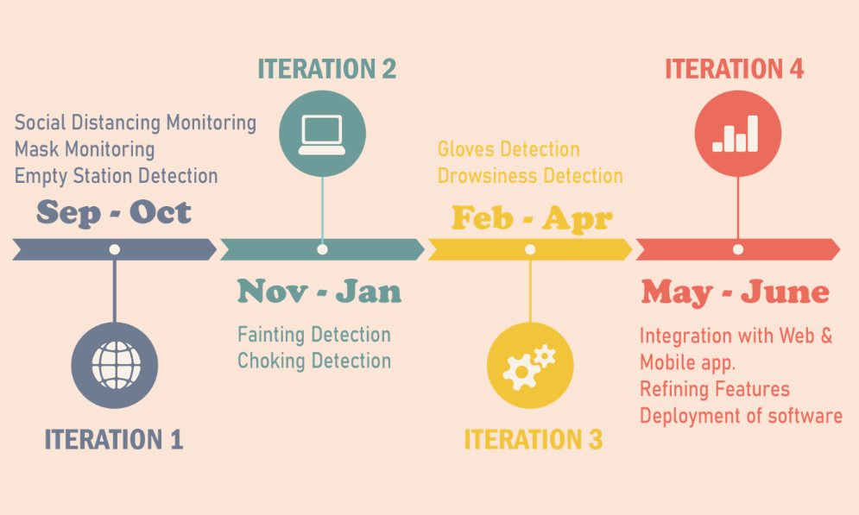

# **High Level Use Cases**

## Use Cases List

|  |  |  |
| --- | --- | --- |
| Use Case ID | Primary Actor | Use Case |
| UC-101 | Admin | View Logs |
| UC-102 | Admin | View Incident |
| UC-103 | Manager, Nurse | Receive Alert |
| UC-104 | System | Detect Person |
| UC-105 | System | Detect Face |
| UC-106 | System | Detect Hands |
| UC-107 | System | Classify Face |
| UC-108 | System | Classify Hands |
| UC-109 | System | Count People |
| UC-110 | System | Calculate Distances |
| UC-111 | System | Classify Action |
| UC-112 | System | Generate Alert |
| UC-113 | System | Generate Incident Logs |
| UC-114 | System | Generate Report |

## Use Cases

|  |  |
| --- | --- |
| **Use Case ID:** | UC-101 |
| **Use Case Name:** | View Logs |
| **Actors:** | Admin |
| **Type:** | Primary |
| **Description:** | Admin will be able to view the logs of incidents i.e., the date and time when something abnormal occurred. |

|  |  |
| --- | --- |
| **Use Case ID:** | UC-102 |
| **Use Case Name:** | View Incident |
| **Actors:** | Admin |
| **Type:** | Primary |
| **Description:** | Admin can view a short clip of any incident that occurred. |

|  |  |
| --- | --- |
| **Use Case ID:** | UC-103 |
| **Use Case Name:** | Receive Alert |
| **Actors:** | Manager, Nurse |
| **Type:** | Primary |
| **Description:** | The hospital staff (manager and nurse) will receive an alert on their phones when the system observes an abnormality. |

|  |  |
| --- | --- |
| **Use Case ID:** | UC-104 |
| **Use Case Name:** | Detect Person |
| **Actors:** | System |
| **Type:** | Primary |
| **Description:** | System will process the camera feed, pass image through trained models and determine if there are people in frame or not. |

|  |  |
| --- | --- |
| **Use Case ID:** | UC-105 |
| **Use Case Name:** | Detect Face |
| **Actors:** | System |
| **Type:** | Primary |
| **Description:** | System will process the camera feed, pass image through trained models and determine if there are faces in frame. |

|  |  |
| --- | --- |
| **Use Case ID:** | UC-106 |
| **Use Case Name:** | Detect Hands |
| **Actors:** | System |
| **Type:** | Primary |
| **Description:** | System will process the camera feed, pass image through trained models and determine if there are hands in frame. |

|  |  |
| --- | --- |
| **Use Case ID:** | UC-107 |
| **Use Case Name:** | Classify Face |
| **Actors:** | System |
| **Type:** | Primary |
| **Description:** | A face detected will be classified as wearing mask or not wearing mask. |

|  |  |
| --- | --- |
| **Use Case ID:** | UC-108 |
| **Use Case Name:** | Classify Hands |
| **Actors:** | System |
| **Type:** | Primary |
| **Description:** | Hands that are detected will be classified as wearing gloves or not wearing gloves. |

|  |  |
| --- | --- |
| **Use Case ID:** | UC-109 |
| **Use Case Name:** | Count People |
| **Actors:** | System |
| **Type:** | Primary |
| **Description:** | System will count the number of people in its vision, from a particular video feed. |

|  |  |
| --- | --- |
| **Use Case ID:** | UC-110 |
| **Use Case Name:** | Calculate Distances |
| **Actors:** | System |
| **Type:** | Primary |
| **Description:** | After detecting multiple people in frame, the distances between them are calculated to determine if they are violating social distancing rules. |

|  |  |
| --- | --- |
| **Use Case ID:** | UC-111 |
| **Use Case Name:** | Classify Action |
| **Actors:** | System |
| **Type:** | Primary |
| **Description:** | Medical abnormalities e.g., choking, fainting are observed by the camera and then classified by the system to check if it actually was that action or not. |

|  |  |
| --- | --- |
| **Use Case ID:** | UC-112 |
| **Use Case Name:** | Generate Alert |
| **Actors:** | System |
| **Type:** | Primary |
| **Description:** | After detecting an abnormality or incident, system will generate an alert and send it to hospital staff. |

|  |  |
| --- | --- |
| **Use Case ID:** | UC-113 |
| **Use Case Name:** | Generate Incident Logs |
| **Actors:** | System |
| **Type:** | Primary |
| **Description:** | After detecting an abnormality or incident, system will generate a record of when it happened and save to database. |

|  |  |
| --- | --- |
| **Use Case ID:** | UC-114 |
| **Use Case Name:** | Generate Report |
| **Actors:** | System |
| **Type:** | Primary |
| **Description:** | After a set interval of time e.g., daily, a report will be generated containing the statistics of the incidents that happened during that interval. |

## Use Case Diagram

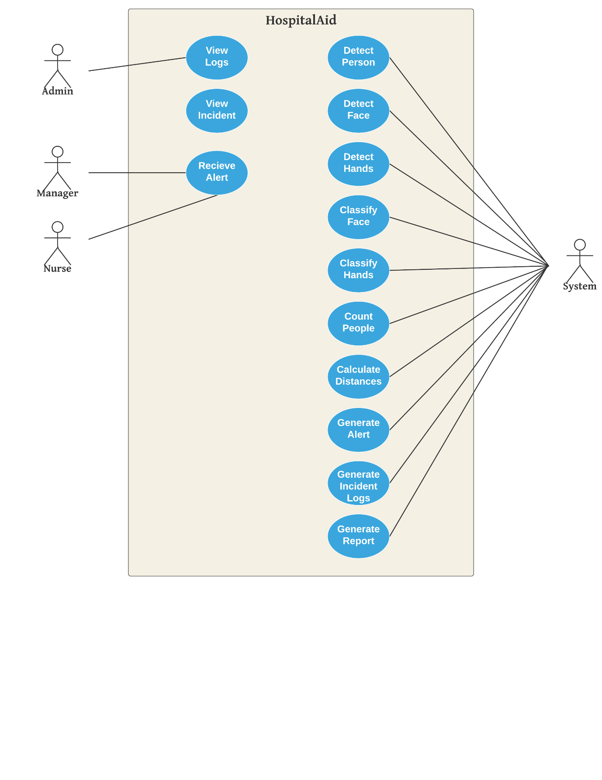

# **Iteration – 1**

## Introduction

In the first iteration, we planned to research and develop some of our simpler features:

* Empty Counter Detection
* Mask SOPs Monitoring
* Social Distance Monitoring

For each feature we had to collect and preprocess our dataset - we used a mix of datasets online, and also filmed our own dataset in an actual hospital environment. All the raw data was appropriately labelled, augmented and saved.

For each feature, we trained different models:

* Empty counter detection required us to check whether there is at least one person present at the area being monitored. We filmed our own dataset of hospital nursing counters and receptions, with a variable number of people. The dataset was then labelled to refer to the people inside the frame. Our model was trained on this dataset so it could predict the presence of a person.
* Mask SOPs Monitoring was done in two phases. The first part required us to identify a face in the image, and the second part was classifying that face as wearing a mask or not. We used a built-in python framework in open-cv to isolate faces, and passed them through a model which was trained on masked and unmasked faces.
* Social distance monitoring used a similar model as in empty counter detection. The goal was to detect people in frame, calculate the distances between them and mark them as either appropriately distanced or not.

## Expanded Use Cases

|  |  |  |  |  |  |
| --- | --- | --- | --- | --- | --- |
| **Use Case ID:** | UC-104 | | | | |
| **Use Case Name:** | Detect Person | | | | |
| **Created By:** | Team HospitalAid | | Last Updated By: | | Team HospitalAid |
| **Date Created:** | Oct 20, 2021 | | Last Revision Date: | | Oct 22, 2021 |
| **Actors:** | | System (Primary) | | | |
| **Description:** | | System will process the live camera feed, pass image through trained models and determine if there are people in frame or not. | | | |
| **Pre-conditions:** | | * Camera should be working * Person(s) is visible in the vision of interest of the camera | | | |
| **Post-conditions:** | | System detects the person(s) in the vision of interest of the camera. | | | |
| **Main Success Scenario:** | | Actor | | System | |
| 1. Person comes in vision of interest of camera | | 1. System detects the person | |
| **Alternative Flows:** | |  | | | |
| **Exceptions:** | | * Camera is not working * Person is at edge of camera’s vision of interest * Camera quality is very poor * Lighting is very dim | | | |
| **Frequency of Use:** | | This may be used for further development where person detection is required. | | | |
| **Special Requirements:** | | Sufficient lighting is required for the camera to view the persons(s) clearly, and the camera should be of adequate quality. | | | |
| **Assumption:** | | Camera is working. | | | |

|  |  |  |  |  |  |
| --- | --- | --- | --- | --- | --- |
| **Use Case ID:** | UC-105 | | | | |
| **Use Case Name:** | Detect Face | | | | |
| **Created By:** | Team HospitalAid | | Last Updated By: | | Team HospitalAid |
| **Date Created:** | Oct 20, 2021 | | Last Revision Date: | | Oct 22, 2021 |
| **Actors:** | | System (Primary) | | | |
| **Description:** | | System will process the live camera feed, pass image through trained models and determine if there are faces in frame or not. | | | |
| **Pre-conditions:** | | * Camera should be working * Human face(s) is visible in the vision of interest of the camera * Faces should not be at very edge of interest or very far from camera | | | |
| **Post-conditions:** | | System detects the face(s) in the vision of interest of the camera. | | | |
| **Main Success Scenario:** | | Actor | | System | |
| 1. Person comes in vision of interest of camera | | 1. System detects the person’s face | |
| **Alternative Flows:** | |  | | | |
| **Exceptions:** | | * Camera is not working * Person is at edge of camera’s vision of interest * Camera quality is very poor * Lighting is very dim | | | |
| **Frequency of Use:** | | This may be used for further development where facial detection is required. | | | |
| **Special Requirements:** | | Sufficient lighting is required for the camera to view the face (s) clearly, and the camera should be of adequate quality. | | | |
| **Assumption:** | | Camera is working. | | | |

## System Sequence Diagrams

### *Use case id: UC-104*

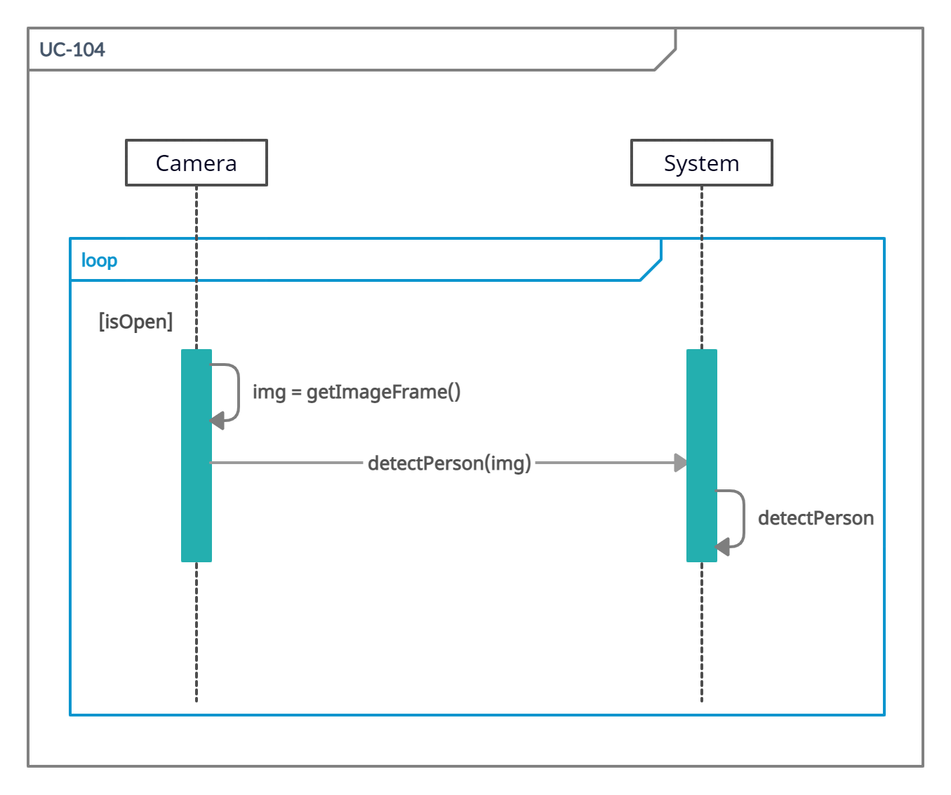

### *Use case id: UC-105*

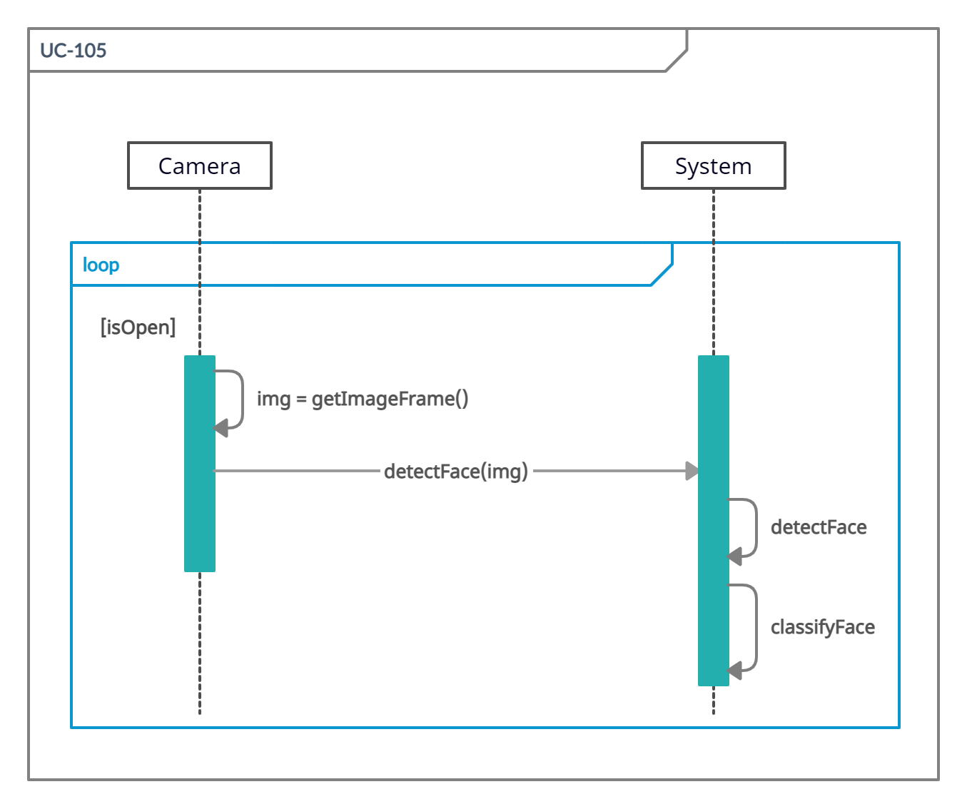

## Operation Contracts

### *Contract use case id: UC-104*

|  |  |
| --- | --- |
| **Operation:** | Detect Person |
| **Cross References:** | UC-105 Detect Face, UC-109 Count People, UC-110 Calculate Distances |
| **Pre-Conditions:**   * The camera is working. * A person is visible in the camera’s vision of interest. | |
| **Post Conditions:**   * Person is detected correctly. * Face is being detected too * Number of people is added into the logs * Distances are calculated | |

### *Contract use case id: UC-105*

|  |  |
| --- | --- |
| **Operation:** | Detect Face |
| **Cross References:** | UC-107 Classify Face |
| **Pre-Conditions:**   * The camera is working. * A person is completely inside the frame. * Face is completely visible. * Lighting conditions are good. | |
| **Post Conditions:**   * Face is classified correctly. * Log is maintained | |

# **Architecture Diagram**

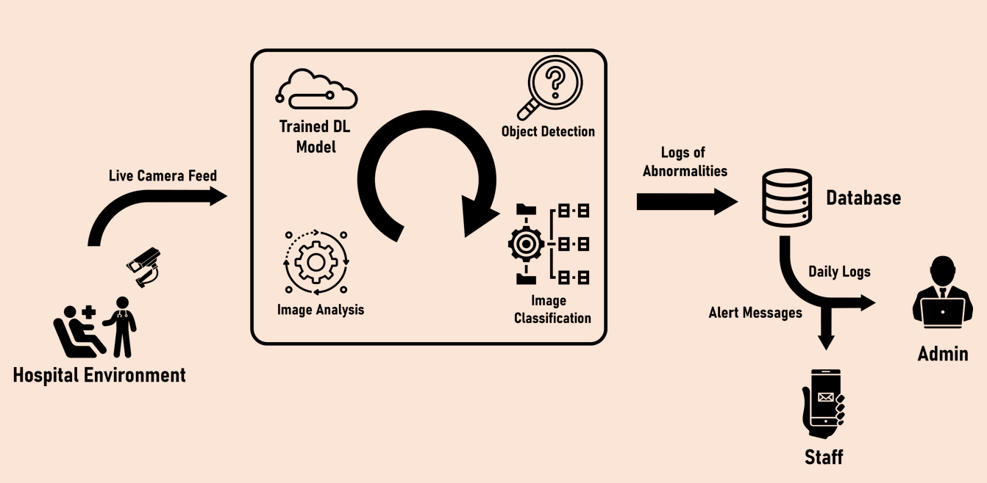

# **Data Flow Diagram**

## Level 0

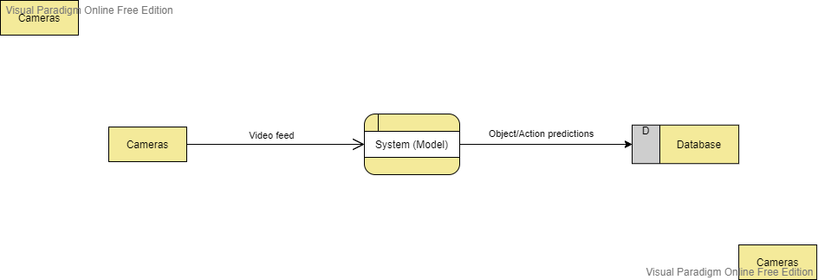

## Level 1

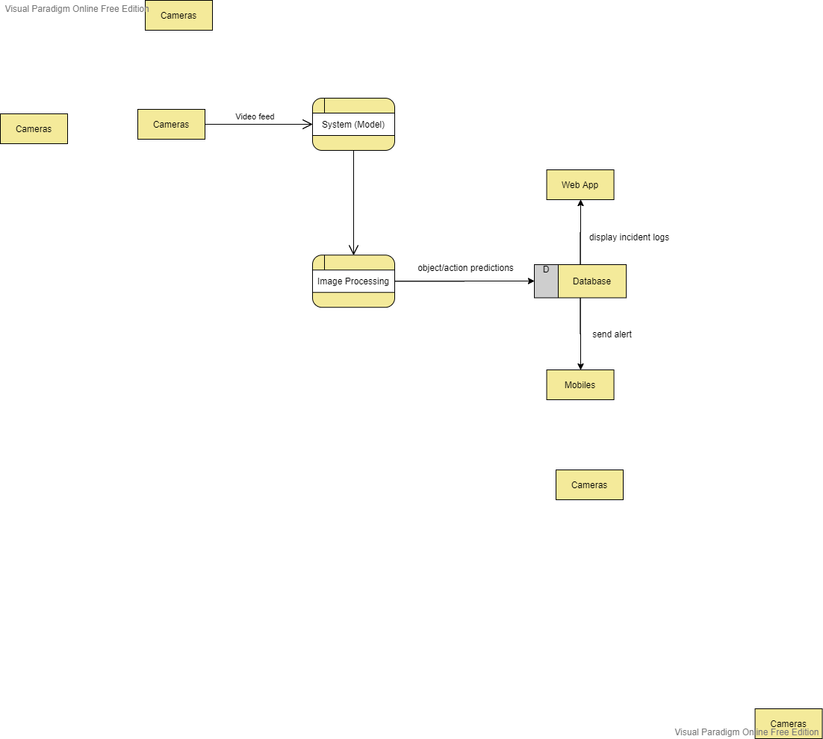

## Level 2

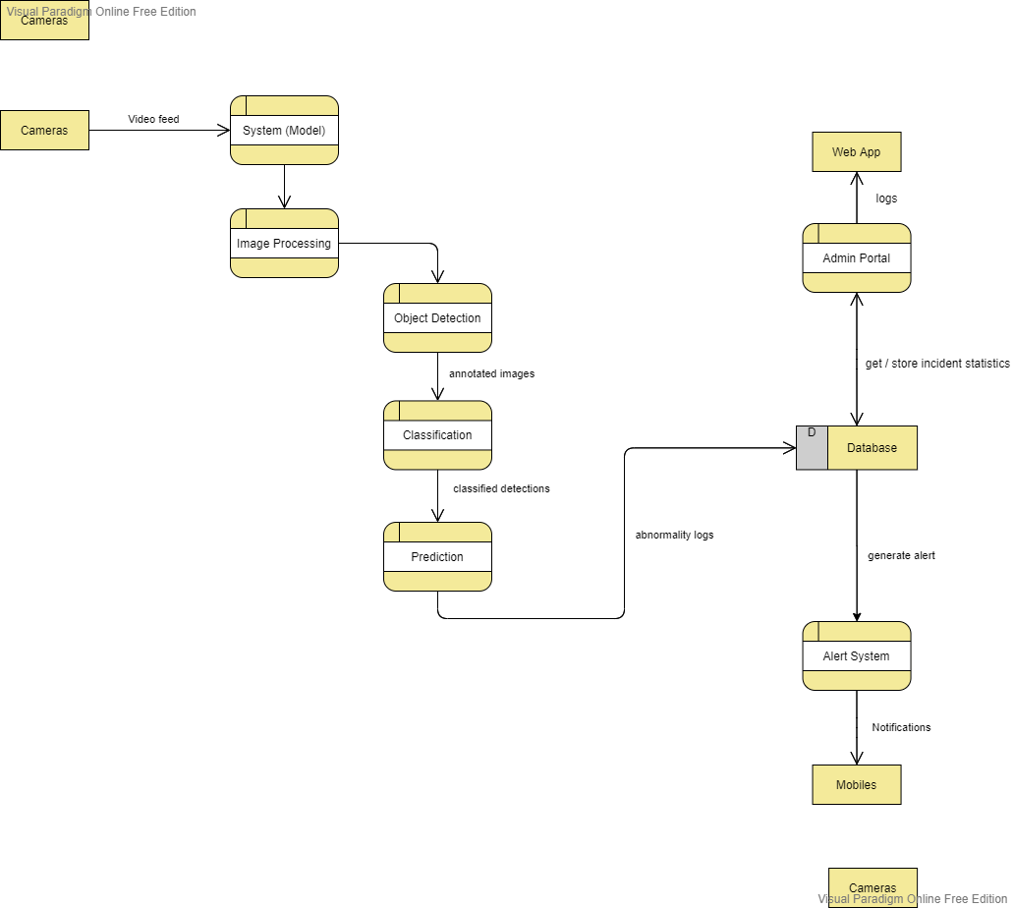

# **Sequence Diagram**

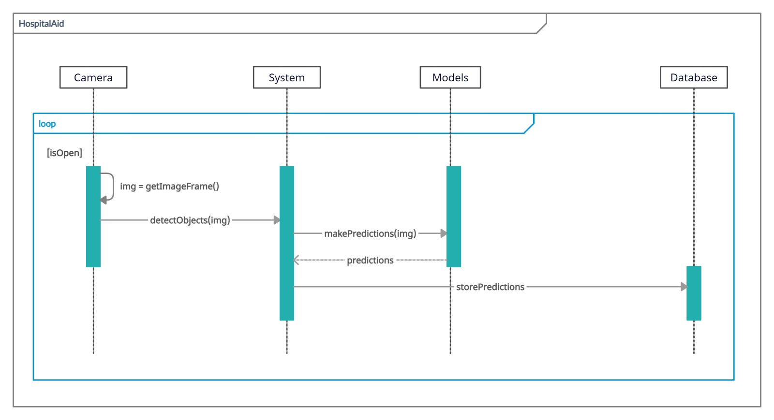

# **Domain Model**

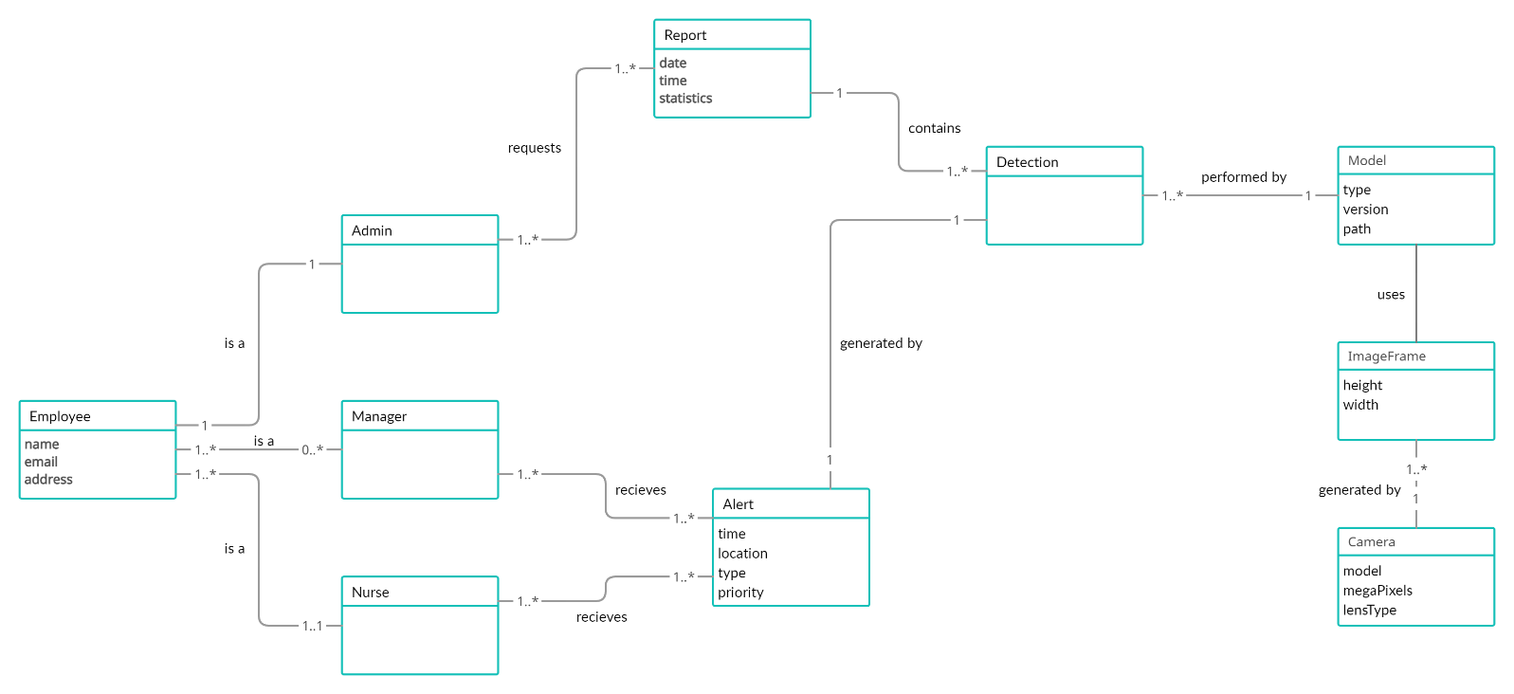

# **Class Diagram**

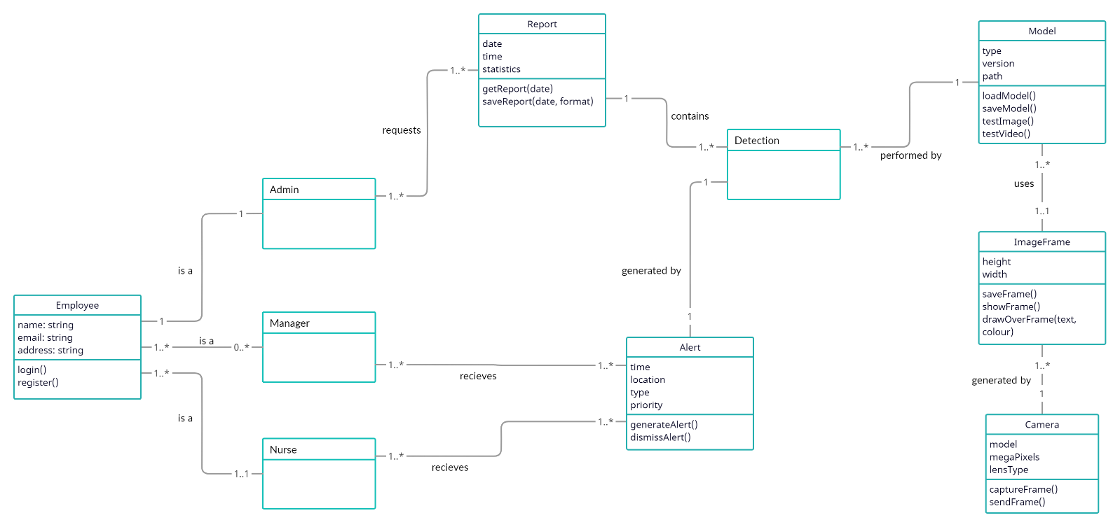

# **Implementation details**

As we had three main features for this iteration, hence, the implementation details for each of the feature is as follows:

## Empty Counter Detection

The implementation of empty counter detection was divided into two phases:

* Dataset Pre-Processing
* Training and Testing of Model

### *Dataset Pre-processing:*

For the pre-processing of dataset, we first needed to gather the dataset. For this, we used CCTV video feeds from the hospitals along with some self-recorded videos. The pre-processing steps are as follows:

* **Division:**
  + **Train Set =** 12000 images
  + **Valid Set =** 509 images
  + **Test Set =** 99 images
* **Pre-Processing:**
  + Auto-Orientation
  + **Resize =** Stretch to 800x360
* **Augmentations:**
  + **Flip =** Horizontal
  + **Rotation =** Between -5° and +5°
  + **Grayscale =** Apply to 10% of images
  + **Hue =** Between -10° and +10°
  + **Saturation =** Between -7% and +7%
  + **Brightness =** Between -9% and +9%
  + **Exposure =** Between -6% and +6%

### *Training and testing of model*

Once we were done with the pre-processing of dataset, the next thing we needed to do was to train our model and design an implementation logic for our model. The logic that we decided was that if even a single person is detected on the counter, then this will be a normal activity for us but if our model is unable to detect any person for a reserved period of time (>= 5 mins), then this will be considered as an abnormal activity and an alert will be generated along with the log being maintained in a file.

Some key points of our implementation are as follows:

* **Framework used:**
  + PyTorch
  + YOLOv5
  + GitHub of Ultralytics
* **System Configurations:**
  + **Processor:** Core i5 7th Generation
  + **RAM:** 64GB
  + **GPU:** 2 – NVIDIA GTX 1070 SLI
  + **OS:** Ubuntu 20.04
  + **Language:** Python 3.8.0
* **Training:**
  + All images cached before the first epoch.
  + **Epochs:** Ran for 52 Epochs. (Started overfitting after that)
  + **Accuracy:** 97.3
  + **Avg Loss:** 0.01593
* **Testing:**
  + Used random videos from hospital and manually recorded ones.
* **Threshold used:** 0.4

## Face Mask Detection

The implementation of face mask detection was divided into two phases:

* Dataset Pre-Processing
* Training and Testing of Model

### *Dataset Pre-processing:*

For the pre-processing of dataset, we first needed to gather the dataset. For this, we used datasets from Kaggle and Roboflow. The pre-processing steps are as follows:

* **Division:**
  + **Train Set =** 815 images
  + **Valid Set =** 129 images
  + **Test Set =** 50 images
* **Pre-Processing:**
  + Auto-Orientation
  + **Resize =** Stretch to 128x128
* **Augmentations:**
  + **Flip =** Horizontal
  + **Rotation =** Between -5° and +5°
  + **Grayscale =** Apply to 10% of images
  + **Hue =** Between -10° and +10°
  + **Saturation =** Between -7% and +7%
  + **Brightness =** Between -9% and +9%
  + **Exposure =** Between -6% and +6%

### *Training and testing of model*

Once we were done with the pre-processing of dataset, the next thing we needed to do was to train our model and design an implementation logic for our model. The logic that we decided was that we had 2 classes : Mask and No-Mask. Our model detects faces and then passes them through the classifier. It will predict the class above a certain threshold which we had set to 0.5 for better predictions.

Some key points of our implementation are as follows:

* **Framework used:**
  + PyTorch
  + YOLOv5
  + GitHub of Ultralytics
* **System Configurations:**
  + **Processor:** Core i5 7th Generation
  + **RAM:** 64GB
  + **GPU:** 2 – NVIDIA GTX 1070 SLI
  + **OS:** Ubuntu 20.04
  + **Language:** Python 3.8.0
* **Training:**
  + All images cached before the first epoch.
  + **Epochs:** Ran for 34 Epochs. (Started overfitting after that)
  + **Accuracy:** 91.2
  + **Avg Loss:** 0.493
* **Testing:**
  + Manually asked some fellow classmates to help us in recording the demo video.
* **Threshold used:** 0.5

## Social Distancing Monitoring

The implementation of social distancing monitoring was divided into two phases:

* Dataset Pre-Processing
* Training and Testing of Model

### *Dataset Pre-processing:*

For the pre-processing of dataset, we first needed to gather the dataset. For this, Microsoft’s COCO dataset . The pre-processing steps are as follows:

* **Division:**
  + **Train Set =** 118K images
  + **Valid Set =** 5K images
  + **Test Set =** 41K images
* **Pre-Processing:**
  + Auto-Orientation
  + **Resize =** Stretch to 800x360
* **Augmentations:**
  + **Flip =** Horizontal
  + **Rotation =** Between -5° and +5°
  + **Grayscale =** Apply to 10% of images
  + **Hue =** Between -10° and +10°
  + **Saturation =** Between -7% and +7%
  + **Brightness =** Between -9% and +9%
  + **Exposure =** Between -6% and +6%

### *Training and testing of model*

Once we were done with the pre-processing of dataset, the next thing we needed to do was to train our model and design an implementation logic for our model. The logic that we decided was that first of all we needed to detect every person in the given frame. So, for this we used COCO’s pre-trained weights to detect people. Once every person was detected, we were calculating the center point of each person. Then the next step was to calculate the Euclidian Distance between two center points. If the distance is less than the set threshold i.e., 150, then it will be marked as a violation of social distancing, else it’s perfectly normal.

Some key points of our implementation are as follows:

* **Framework used:**
  + PyTorch
  + YOLOv5
  + GitHub of Ultralytics
* **System Configurations:**
  + **Processor:** Core i5 7th Generation
  + **RAM:** 64GB
  + **GPU:** 2 – NVIDIA GTX 1070 SLI
  + **OS:** Ubuntu 20.04
  + **Language:** Python 3.8.0
* **Testing:**
  + Used demo video from : <https://www.epfl.ch/labs/cvlab/data/data-pom-index-php/> and some self-recorded videos.
* **Threshold used:** 0.5

## Backend Algorithm (YOLO)

### *Why Choose YOLO?*

When selecting an algorithm to use for object detection, the most important metric for our system is speed – the live video feed has to be analysed as quickly as possible, with good accuracy of results. A slow algorithm would mean a delay in abnormality detections, which would defeat the purpose of our system.

Tradition object detection systems are typically based on classifiers. They apply the classifier model to different parts of the image separately, and if a region has a high score this indicates an object was detected there. This requires multiple evaluations, as various parts of the image are passed through the neural network. Naturally this leads to slow speed of detection.

The novel thing about YOLO is that it only propagates the image once through the neural network. The image is divided into regions, but the regions are processed simultaneously. Bounding boxes are predicted for the objects detected, with each box having an associated probability or confidence of detection (0-1). This process (and single pass of network) makes YOLO extremely fast, with a speed of at least 45 frames per second.

### *How YOLO Works*

Yolo works by applying the following techniques:

* Residual blocks:
  + Image is divided into grids/cells
  + Every cell detects objects inside it
  + Cell with object center is responsible for detecting that object
* Bounding box regression
  + A box is formed around an object
  + Box has width, height, center coordinates, and probability of object being in this box
* Intersection over Union (IoU)
  + Caters for multiple bounding boxes for one object
  + The IoU score (with the actual, labelled box) is calculated for each predicted box
  + An IoU score of 1 indicates the predicted box is equivalent to real box
  + All other predicted boxes are discarded

In just one pass of the neural network, the image is divided into cells, bounding boxes predicted for each cell, IoU applied to remove overlapping boxes – and for the final result, we have boxes that perfectly fit the objects.

### *YOLO Architecture*

There are three main components in the model: the head, neck and backbone. The backbone layer is trained on a classification dataset and is responsible for detecting key features of an image. The neck layer makes predictions on bounding box coordinates and class probabilities. The head layer is the final output layer of the network.

# **References**

AIZOOTech. (n.d.). AIZOOTech/facemaskdetection: detect faces and determine whether people are wearing mask. GitHub. Retrieved October 22, 2021, from https://github.com/AIZOOTech/FaceMaskDetection.

AlexeyAB. (n.d.). Alexeyab/Darknet: Yolov4 / scaled-yolov4 / yolo - neural networks for object detection (windows and linux version of darknet ). GitHub. Retrieved October 22, 2021, from https://github.com/AlexeyAB/darknet.

Balajisrinivas. (n.d.). Balajisrinivas/face-mask-detection: Detecting face masks using python, keras, opencv on real video streams. GitHub. Retrieved October 22, 2021, from https://github.com/balajisrinivas/Face-Mask-Detection.

Bochkovskiy, A., Wang, C.-Y., &amp; Liao, H.-Y. M. (2020, April 23). YOLOv4: Optimal Speed and Accuracy of Object Detection. Retrieved from https://arxiv.org/abs/2004.10934.

Cabani, A., Hammoudi, K., Behnhabiles, H., & Melkemi, M. (2021). MaskedFace-Net – A dataset of correctly/incorrectly masked face images in the context of COVID-19. Smart Health, 19. <https://doi.org/https://doi.org/10.1016/j.smhl.2020.100144>

Cocodataset. (n.d.). Cocodataset/cocodataset.github.io. GitHub. Retrieved October 22, 2021, from https://github.com/cocodataset/cocodataset.github.io.

Fall detection. imvia. (2020, April 20). <https://imvia.u-bourgogne.fr/en/database/fall-detection-dataset-2.html>

Ghoddoosian, R., Marnim, G., &amp; Athitsos, V. (2019, April 15). A Realistic Dataset and Baseline Temporal Model for Early Drowsiness Detection. Retrieved from https://arxiv.org/abs/1904.07312.

Gul, M. A., Yousaf, M. H., Nawaz, S., Ur Rehman, Z., & Kim, H. W. (2020). Patient monitoring by abnormal human activity recognition based on CNN Architecture. *Electronics*, *9*(12), 1993. https://doi.org/10.3390/electronics9121993

K, G. (2020, June 11). COVID-19: AI-Enabled Social Distancing Detector using OpenCV. towards data science. Retrieved from <https://towardsdatascience.com/covid-19-ai-enabled-social-distancing-detector-using-opencv-ea2abd827d34>.

Khan, W., Nawaz, F., &amp; Hussain, A. (2020, November 12). Video Dataset for COVID-19 Social Distancing and Human Detection Validation. Retrieved from DOI: 10.17632/xh6m6gxhvj.1.

Loey, M. (2021, February 15). COVID-19 Medical Face Mask Detection Dataset. kaggle. <https://www.kaggle.com/mloey1/medical-face-mask-detection-dataset>.

Redmon, J., & Farhadi, A. (2018). (tech.). *YOLOv3: An Incremental Improvement*. Retrieved from https://arxiv.org/abs/1804.02767.

Singh, S., Ahuja, U., Kumar, M., Kumar, K., & Sachdeva, M. (2021). Face mask detection using yolov3 and faster R-CNN models: COVID-19 environment. *Multimedia Tools and Applications*, *80*(13), 19753–19768. https://doi.org/10.1007/s11042-021-10711-8

Yang, Y., Sarkis, R. A., El Atrache, R., Loddenkemper, T., & Meisel, C. (2021). Video-Based Detection of Generalized Tonic-Clonic Seizures Using Deep Learning. IEEE Journal of Biomedical and Health Informatics, 25(8), 2997–3008. <https://doi.org/10.1109/JBHI.2021.3049649>

Yang, D., Yurtsever, E., Renganathan, V., Redmill, K. A., &amp; Özgüner, Ü. (2021, July 5). A Vision-based social distancing and critical density detection system for covid-19. MDPI. Retrieved October 21, 2021, from https://www.mdpi.com/1424-8220/21/13/4608.

Ultralytics. (n.d.). Ultralytics/yolov5: Yolov5 in PyTorch &gt; ONNX &gt; CoreML &gt; TFLite. GitHub. Retrieved October 22, 2021, from https://github.com/ultralytics/yolov5.